Experiment 1:- Basic Plots Using Matplotlib Package

1. Aim | 5. Program
2. Software Required | 6. Results
3. Prerequisite | 7. Experimentation Questions

4. Introduction

- Aim: -
Demonstrate all the basic plots using Matplotlib package and python programming.

- Software Required:-
- Operating System: Windows 10
- Software Required: Jupyter Notebook

- Pre-Requisites:-
- Basics of Python Programming,
- Concept of Matplotlib Package

- Introduction:-
Matplotlib is a powerful and widely used Python library for creating static, animated, and interactive visualizations. It provides a flexible framework for generating a variety of plots and charts to help visualize data effectively.

- Program:-
import matplotlib.pyplot as plt
import numpy as np

# Generate some data for plotting
x = np.linspace(0, 10, 100)
y = np.sin(x)
plt.figure()
plt.plot(x,y)
plt.title("Line Chart")
categories=['A','B','C','D'] values=[20,35,30,25] plt.figure() plt.bar(categories,values) plt.title("Bar Chart")
x=np.random.randn(100)
y=np.random.randn(100) colors=np.random.rand(100)
sizes=100*np.random.rand(100) plt.figure()
plt.scatter(x,y,c=colors, s=sizes, alpha=0.5)
plt.title("Scatter Plot")
sizes = [30, 20, 25, 15, 10]
labels = ['A', 'B', 'C', 'D', 'E']
plt.figure()
plt.pie(sizes, labels=labels, autopct="%1.1f%%") plt.title("Pie Chart")
plt.show()
- Result:-
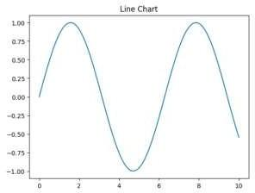
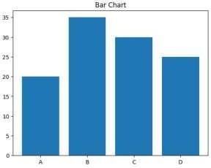
Output:-
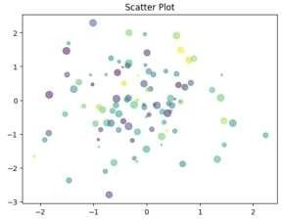
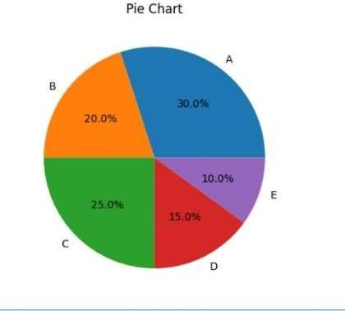

- Experimental Question:-
- What is Matplotlib?
- What is Matplotlib, and why is it used in Python?
- What is the purpose of a line plot in data visualization?
- How does a bar plot differ from a line plot?
- What is the use of a scatter plot?

Experiment 2:- File Operations on Excel Dataset

1. Aim | 5. Program
2. Software Required | 6. Results
3. Prerequisite | 7. Experimentation Questions

4. Introduction

- Aim: -
Implement a python program to perform File Operations on Excel Dataset.

- Software Required:-
- Operating System: Windows 10
- Software Required: Jupyter Notebook

- Pre-Requisites:-
- Basics of Python Programming,
- Basic Knowledge of Excel

- Introduction:-
File operations on Excel datasets involve various tasks such as reading, writing, and manipulating data stored in Excel files. Excel files are commonly used for storing structured data in rows and columns, making them suitable for organizing datasets.

- Program:-
import pandas as pd
df=pd.read_excel('data.xlsx')
print("First few rows")
print(df.head())
print("\n Summary statistics:")
print(df.describe())
filtered_data=df[df['Age']>30]
print("\n Filtered data(Age>30):")
print(filtered_data)
sorted_data=df.sort_values(by='salary',ascending=False)
print("\nSorteddata(by Salary):")
print(sorted_data)
df['Bonus']=df['salary']*0.1
print("\n Data with new column(Bonus)")
print(df)
df.to_excel('Output.xlsx',index=False)
print("\n Data written to output.xlsx")

- Result:-
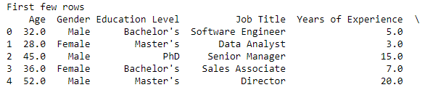
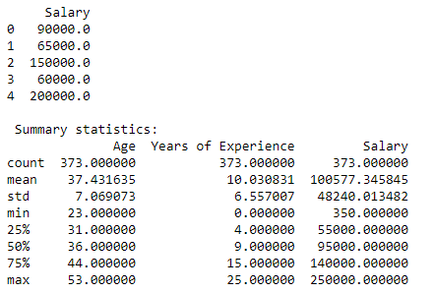
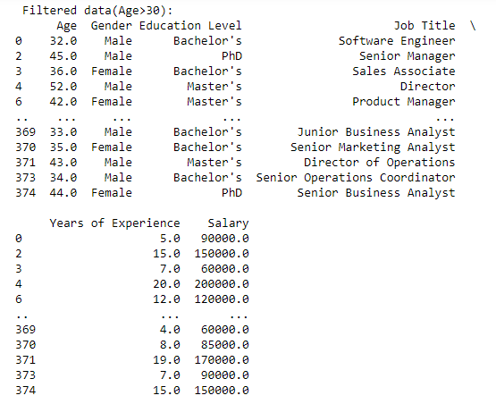
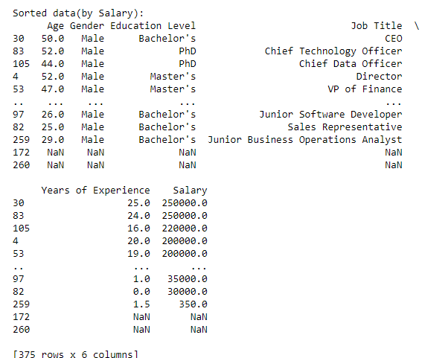

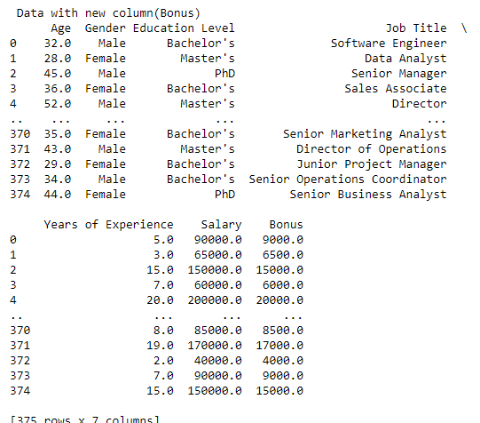

- Experimental Question:-
- What method is used to save the workbook to a specific file?
- How do you add data to an Excel sheet in Python?
- How can you read data from an Excel sheet in Python?
- How do you update an existing value in an Excel sheet?
- How do you load an existing Excel workbook?

Experiment 3:- Array operations using the Numpy package
1. Aim | 5. Program
2. Software Required | 6. Results
3. Prerequisite | 7. Experimentation Questions

4. Introduction

- Aim: -
Write a python program to perform Array operations using the Numpy package.

- Software Required:-
- Operating System: Windows 10
- Software Required: Jupyter Notebook

- Pre-Requisites:-
- Basics of Python Programming,
- Basic Math Knowledge

- Introduction:-
Array operations using the NumPy package involve performing efficient and powerful computations on arrays, which are collections of elements (usually numbers) organized in a grid or matrix format. NumPy is a fundamental package in Python for scientific computing, and it provides a wide range of tools to create, manipulate, and perform mathematical operations on arrays.

- Program:-
import numpy as np
# Create two sample arrays
array1 = np.array([[1, 2, 3], [4, 5, 6]])
array2 = np.array([[7, 8, 9], [10, 11, 12]])
print("Array 1:")
print(array1)
print("\nArray 2:")
print(array2)
# Addition
array_addition = array1 + array2
print("\nAddition of Array 1 and Array 2:")
print(array_addition)
# Subtraction
array_subtraction = array1 - array2
print("\nSubtraction of Array 1 and Array 2:")
print(array_subtraction)

# Multiplication (element-wise)
array_multiplication = array1 * array2
print("\nElement-wise Multiplication of Array 1 and Array 2:")
print(array_multiplication)
# Transpose of Array 1
array_transpose = np.transpose(array1)
print("\nTranspose of Array 1:")
print(array_transpose)
# Reshape Array 1 from (2, 3) to (3, 2)
array_reshaped = array1.reshape(3, 2)
print("\nReshaped Array 1 (from 2x3 to 3x2):")
print(array_reshaped)
# Calculate Mean
mean_array1 = np.mean(array1)
print("\nMean of Array 1:")
print(mean_array1)
# Calculate Median
median_array1 = np.median(array1)
print("\nMedian of Array 1:")
print(median_array1)

# Calculate Min and Max
min_value = np.min(array1)
max_value = np.max(array1)
print("\nMin and Max of Array 1:")
print("Min:", min_value)
print("Max:", max_value)

# Calculate Standard Deviation
std_deviation = np.std(array1)
print("\nStandard Deviation of Array 1:")
print(std_deviation)

- Result:-
Output:-
[[1 2 3]
[4 5 6]]

Array 2:
[[ 7 8 9]
[10 11 12]]

Addition of Array 1 and Array 2:
[[ 8 10 12]
[14 16 18]]

Subtraction of Array 1 and Array 2:
[[-6 -6 -6]
[-6 -6 -6]]
Element-wise Multiplication of Array 1 and Array 2:
[[ 7 16 27]
[40 55 72]]
Transpose of Array 1:
[[1 4]
[2 5]
[3 6]]

Reshaped Array 1 (from 2x3 to 3x2):
[[1 2]
[3 4]
[5 6]]

Mean of Array 1:

Median of Array 1:
3.5

Min and Max of Array 1:
Min: 1
Max: 6

Standard Deviation of Array 1:
1.707825127659933

- Experimental Question:-
- What is NumPy, and why is it used in Python?
- How do you install the NumPy package in Python?
- How do you create arrays in NumPy?
- How do you create a one-dimensional array in NumPy?
- How do you perform addition, subtraction, and multiplication of two arrays in NumPy?

Experiment 4:- Back propagation Algorithm
1. Aim | 5. Program
2. Software Required | 6. Results
3. Prerequisite | 7. Experimentation Questions

4. Introduction

- Aim: -
Build an Artificial Neural Network by implementing the Backpropagation algorithm and test the same using appropriate data sets.
- Software Required:-
- Operating System: Windows 10
- Software Required: Jupyter Notebook
- Pre-Requisites:-
- Basics of Python Programming
- Basic Mathematics

- Introduction:-
The Backpropagation Algorithm is a fundamental technique used in training artificial neural networks. It is an optimization method designed to minimize the error in the network’s predictions by adjusting the weights of connections between neurons.

- Program:-
import numpy as np
x=np.array(([2,9],[1,9],[3,6]),dtype=float)
y=np.array(([92],[86],[89]),dtype=float)
x=x/np.amax(x,axis=0)
y=y/100

def sigmoid(x):
return 1/(1+np.exp(-x))
def derivation_sigmoid(x):
return x*(1-x)
epoch=5000
lr=0.1
inputlayer_neurons=2
hiddenlayer_neurons=3
outputlayer_neurons=1

wb=np.random.uniform(size=(inputlayer_neurons,hiddenlayer_neurons)) bb=np.random.uniform(size=(1,hiddenlayer_neurons)) wout=np.random.uniform(size=(hiddenlayer_neurons,outputlayer_neurons)) bout=np.random.uniform(size=(1,outputlayer_neurons))
for i in range(epoch):
hinp1=np.dot(x,wb)
hinp=hinp1+bb hlayer_act=sigmoid(hinp) outinp1=np.dot(hlayer_act,wout) outinp=outinp1+bout output=sigmoid(outinp)

EO=y-output outgrad=derivation_sigmoid(output) d_output=EO*outgrad EH=d_output.dot(wout.T) hiddengrad=derivation_sigmoid(hlayer_act) d_hiddenlayer=EH*hiddengrad wout+=hlayer_act.T.dot(d_output)*lr wb+=x.T.dot(d_output)*lr

print("Inpput:\n" +str(x)) print("Actual:\n"+str(y)) print("Predicted:\n",output)

- Result:-
Output:-
Input:
[[0.66666667 1. ]
[0.33333333 1. ]
[1. 0.66666667 ]]
Actual:
[[0.92
[0.86]
[0.89]]

Predicted: [[0.89184048]
[0.88433366]

[0.89399225]]

- Experimental Question:-
- What is Back propagation in Neural Networks?
- How does back propagation help in adjusting weights in neural networks?
- What are the key components of an Artificial Neural Network?
- What is the purpose of learning rate in back propagation?
- What are the layers in an artificial neural network, and what are their functions?

Experiment 5:-Linear Regression operation
1. Aim | 5. Program
2. Software Required | 6. Results
3. Prerequisite | 7. Experimentation Questions

4. Introduction

- Aim: -
Demonstrate Linear Regression operation using python programming.

- Software Required:-
- Operating System: Windows 10
- Software Required: Jupyter Notebook

- Pre-Requisites:-
- Basics of Python Programming,
- Basic Knowledge of Statistics
- Understanding of Linear Algebra

- Introduction:-
Linear Regression is a simple and widely used machine learning algorithm that models the relationship between a dependent variable (target) and one or more independent variables (features). It aims to find the best-fitting straight line through the data points, which can be used to predict the target variable based on the input features.

- Program:-
import pandas as pd
import numpy as np
import matplotlib.pyplot as plt import seaborn as sns
dataset = pd.read_csv('advertising.csv')
dataset.head(10)
dataset.shape dataset.isna().sum()
dataset.duplicated().any()
fig, axs = plt.subplots(3, figsize = (5,5))
plt1 = sns.boxplot(dataset['TV'], ax = axs[0])
plt2 = sns.boxplot(dataset['Newspaper'], ax = axs[1])
plt3 = sns.boxplot(dataset['Radio'], ax = axs[2])
plt.tight_layout()
sns.distplot(dataset['Sales']);

sns.pairplot(dataset, x_vars=['TV', 'Radio', 'Newspaper'], y_vars='Sales', height=4, aspect=1, kind='scatter')
plt.show()
sns.heatmap(dataset.corr(), annot = True)
plt.show()
from sklearn.model_selection import train_test_split
from sklearn.linear_model import LinearRegression
from sklearn import metrics
x= dataset[['TV']]
y= dataset['Sales']
x_train, x_test, y_train, y_test = train_test_split(x, y, test_size = 0.3, random_state = 100) slr= LinearRegression()
slr.fit(x_train, y_train)
print('Intercept:', slr.intercept_)
print('Coefficient:', slr.coef_)
print('Regression Equation: Sales = 6.948 + 0.054 * TV')
plt.scatter(x_train, y_train)
plt.plot(x_train, 6.948 + 0.054*x_train, 'r')
plt.show()
#Prediction of Test and Training set result
y_pred_slr= slr.predict(x_test)
x_pred_slr= slr.predict(x_train)
print("Prediction for test set: {}".format(y_pred_slr))
slr_diff = pd.DataFrame({'Actual value': y_test, 'Predicted value': y_pred_slr})
slr_diff
#Predict for any value slr.predict([[56]])
# print the R-squared value for the model
from sklearn.metrics import accuracy_score
print('R squared value of the model: {:.2f}'.format(slr.score(x,y)*100))

- Result:-
Output:-
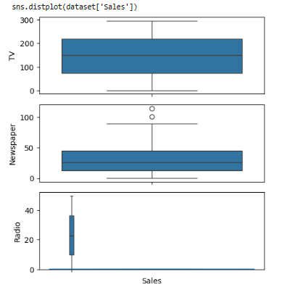
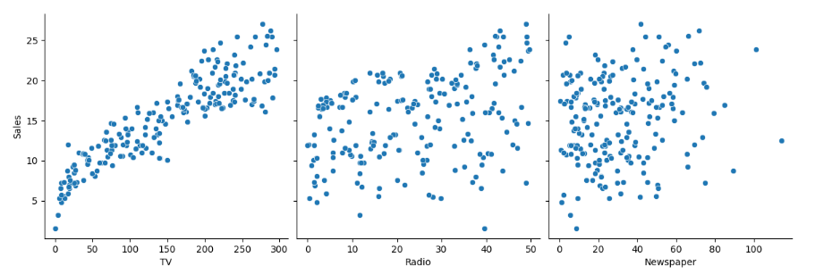

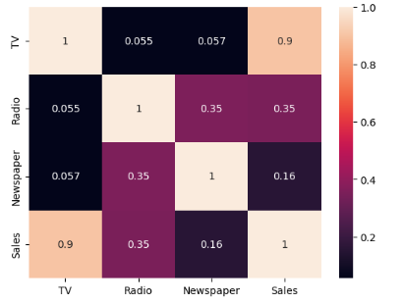

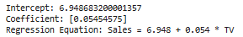
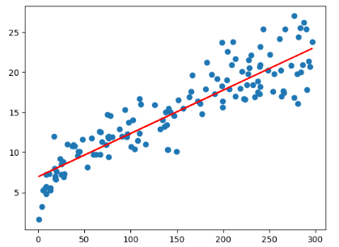
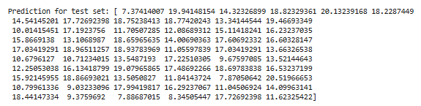
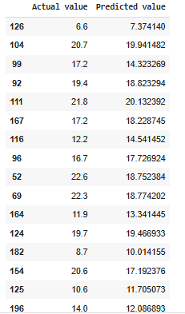

- Experimental Question:-
- What is Linear Regression?
- What is the output of the predict() function?
- How is the Linear Regression model used in the program?
- How is the R-squared value interpreted in Linear Regression?
- What is the output of the predict() function?

Experiment 6:- Logistic Regression Classifier

1. Aim | 5. Program
2. Software Required | 6. Results
3. Prerequisite | 7. Experimentation Questions

4. Introduction

- Aim: -
Train a regularized logistic regression classifier on the in-build iris dataset using scikit-learn. Train the model and report the best classification accuracy.

- Software Required:-
- Operating System: Windows 10
- Software Required: Jupyter Notebook

- Pre-Requisites:-
- Basics of Python Programming

- Introduction:-
Logistic Regression is a statistical method used for binary classification, which means it predicts one of two possible outcomes based on input features. Despite its name, it is used for classification tasks rather than regression.

- Program:-
# Importing the necessary
libraries import numpy as np
import matplotlib.pyplot as plt
import pandas as pd
# Importing the dataset
dataset = pd.read_csv('iris.csv')
dataset.describe() dataset.info()
# Splitting the dataset into the Training set and Test set
X = dataset.iloc[:, [0,1,2, 3]].values
y = dataset.iloc[:, 4].values

from sklearn.model_selection
import train_test_split
X_train, X_test, y_train, y_test = train_test_split(X, y, test_size = 0.25, random_state = 0)
# Feature Scaling
from sklearn.preprocessing
import StandardScaler sc = StandardScaler()
X_train = sc.fit_transform(X_train) X_test = sc.transform(X_test)
# Fitting Logistic Regression to the Training set

from sklearn.linear_model import LogisticRegression

classifier = LogisticRegression(random_state = 0, solver='lbfgs', multi_class='auto')
classifier.fit(X_train, y_train)
# Predicting the Test set results
y_pred = classifier.predict(X_test)
# Predict probabilities
probs_y=classifier.predict_proba(X_test) probs_y = np.round(probs_y, 2)
res = "{:<10} | {:<10} | {:<10} | {:<13} | {:<5}".format("y_test", "y_pred", "Setosa(%)", "versicolor(%)", "virginica(%)\n")
res += "-"*65+"\n"

res += "\n".join("{:<10} | {:<10} | {:<10} | {:<13} | {:<10}".format(x, y, a, b, c) for x, y, a, b, c in zip(y_test, y_pred, probs_y[:,0], probs_y[:,1], probs_y[:,2]))
res += "\n"+"-"*65+"\n" print(res)
# Making the Confusion Matrix

from sklearn.metrics
import confusion_matrix cm = confusion_matrix(y_test, y_pred)
print(cm)
# Plot confusion matrix
import seaborn as sns
import pandas as pd
# confusion matrix sns heatmap
## https://www.kaggle.com/agungor2/various-confusion-matrix-plots
ax = plt.axes()
df_cm = cm
sns.heatmap(df_cm, annot=True, annot_kws={"size": 30}, fmt='d',cmap="Blues", ax = ax ) ax.set_title('Confusion Matrix')
plt.show()

- Result:-
Output:-
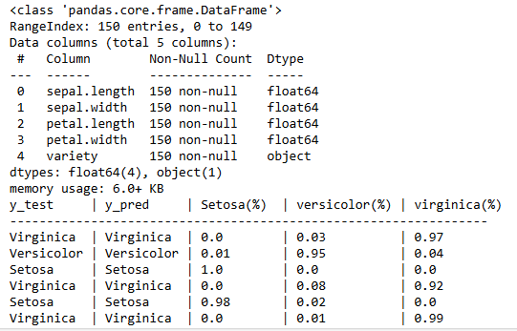

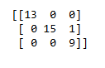
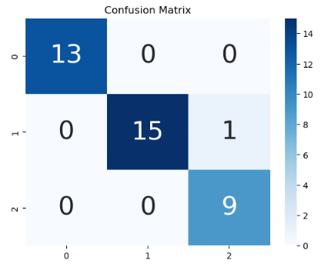

- Experimental Question:-
- What is Logistic Regression, and how does it work?
- What type of problems is Logistic Regression used for?
- What are the features of the Iris dataset?
- How many species of Iris are there in the dataset?
- What could happen if you train and test on the same dataset?

Experiment 7:- Data Manipulation operations
1. Aim | 5. Program
2. Software Required | 6. Results
3. Prerequisite | 7. Experimentation Questions

4. Introduction

- Aim: -
Write a python program to perform Data Manipulation operations using Pandas package.

- Software Required:-
- Operating System: Windows 10
- Software Required: Jupyter Notebook

- Pre-Requisites:-
- Basics of Python Programming
- Introduction:-
Pandas is one of the most widely used open-source libraries in Python for data manipulation and analysis. It provides two primary data structures: Series (1-dimensional) and DataFrame (2-dimensional). Pandas allows users to efficiently manipulate, analyze, and visualize data, especially structured data such as tabular data (spreadsheets, SQL databases, CSV files, etc.).
- Program:-
import pandas as pd
data={'Name':['John','Emma','Sant','Lisa','Tom'],
'Age':[25,30,28,32,27],
'Country':['USA','Canada','India','UK','Australia'], 'Salary':[50000,60000,70000,80000,65000]
}
df=pd.DataFrame(data) print("Original DataFrame") print(df)

name_age=df[['Name','Age']]
print("Original DataFrame")
print(df) name_age=df[['Name','Age']]
print("Name and Age columns")
print(name_age)
filtered_df=df[df['Country']=='USA']
print("\nfiltered DataFrame(Country='USA')")
print(filtered_df)
sorted_df=df.sort_values("Salary",ascending=False) print("\nsorted DataFrame(by ssalary in descending order)") print(sorted_df)
average_Salary=df['Salary'].mean()

print("\nAverage salary",average_Salary)
df['Experience']=[3,6,4,8,5] print("\nDataFrame with added experience") print(df) df.loc[df['Name']=='Emma','Salary']=65000
print("\nDataFrame with updating emma salary")
print(df)

df.drop('Experience',axis=1) print("\nDataFrame after deleting the column ")
print(df)

- Result:-
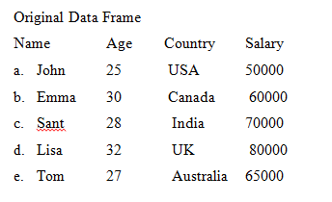
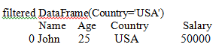

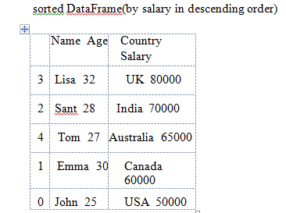
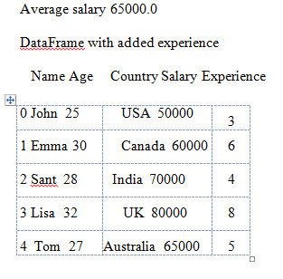


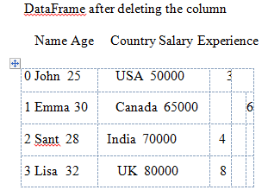
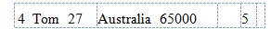

- Experimental Question:-
- What is Pandas and why is it important in data analysis?
- What are the key features of the Pandas library in Python?
- What types of data does Pandas handle?
- How do you create a DataFrame in Pandas?
- What are the default sorting options in Pandas?

Experiment 8:- MapReduce Program

1. Aim | 5. Program
2. Software Required | 6. Results
3. Prerequisite | 7. Experimentation Questions

4. Introduction

- Aim: -
Develop a MapReduce program to find the grades of students in python.
- Software Required:-
- Operating System: Windows 10
- Software Required: Jupyter Notebook

- Pre-Requisites:-
- Basics of Python Programming,
- Basic Programming Skills

- Introduction:-
Data manipulation operations involve techniques used to process and transform data to make it more useful for analysis and decision-making.

- Program:-
import csv
from mrjob.job import MRJob
class MRStudentGrades (MRJob):
# Mapper function: Process input data and compute average marks def mapper(self,_, line):
# Using csv.reader to parse the CSV line
reader = csv.reader([line])
for data in reader:
# Extract student name and marks (assuming marks are integers) name = data[0].strip()
marks = list(map(int, data[1:])) # Convert marks to integers
# Calculate the average of the marks
average=sum(marks)/ len(marks)
# Emit student name as key, and average marks as value yield name, average
# Reducer function: Assign grades based on average marks
def reducer(self, key, values):
# There will be only one average value per student
average = list(values)[0]
# Determine the grade based on average marks
if average >= 90:
grade = 'A+'
elif average >= 80:
grade = 'A'
elif average >= 70:
grade = 'B+' elif average >= 60:
grade = 'B'
elif average >= 50:
grade = 'C+'
elif average >= 40:
grade = 'C'
else:
grade = 'F'
# Yield student name and their grade

Pending pgm

- Result:-

- Experimental Question:-
- What is MapReduce, and how does it work?
- What are the roles of the "Map" and "Reduce" functions in MapReduce?
- Why is MapReduce useful in processing large datasets?
- What would the Reduce function do in the same job?
- What would the output of the map() function look like in this scenario?

